CS 121 Homework 2

John Ingram

9/11/19

**Program 1.**

**Using only the following create a pyramid design composed of asterisks**

**Code:**

//

// Program1

//

#include <iostream>

#include <fstream>

#include <iomanip>

#include <string>

using namespace std;

int main(void)

{

unsigned int maxWidth = 0, currentWidth, currentStars = 1;

char star = '*', space = ' ';

cout << "Enter the width of the pyramid you'd like to create (The number must be odd for propper formating): ";

cin >> maxWidth;

maxWidth++;

for (currentWidth = maxWidth / 2; currentStars <= maxWidth; currentWidth--)

{

cout << setfill(space) << setw(currentWidth) << space << string(currentStars, star) << setfill(space) << endl;

currentStars += 2;

}

system("pause");

return 0;

}

**Output:**

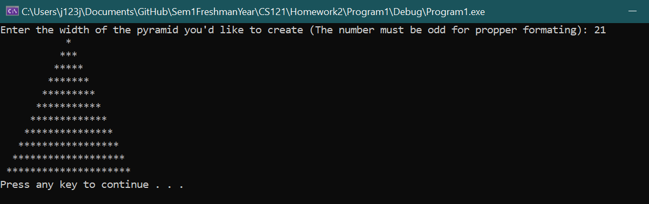

**Program 2.**

**Write a program that generates a table showing the powers of two as shown below. The powers of two should range from 0 to 31.  Do not use the pow function to compute the powers of 2. You must use a loop that actually multiplies some variable be 2 each pass through the loop.  ex: power2 = power2 * 2. (Initialize power2 to 1 to begin of course.)**

**Code:**

//

// Program 2

//

#include <iostream>

#include <fstream>

#include <iomanip>

#include <string>

using namespace std;

int main(void)

{

unsigned int value = 0;

cout << right << setw(2) << "n" << setw(15) << "VALUE OF 2^n" << endl;

for (int n = 0; n <= 31; n++)

{

if (n == 0) value = 1;

else

{

value = 2;

for (int i = 0; i < n-1; i++) value *= 2;

}

cout << setw(2) << n << setw(15) << value << endl;

}

system("pause");

return 0;

}

**Output:**

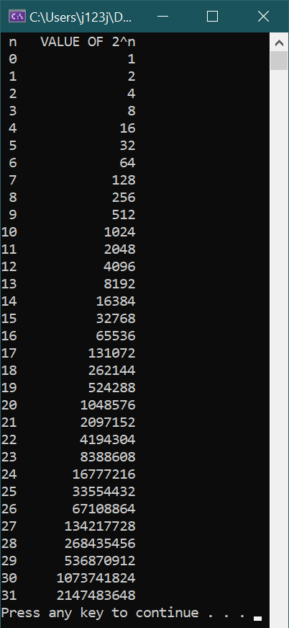

**Program 3.**

**Write a program that converts a time in 12-hour format to 24-hour format. The program will prompt the user to enter a time in HH:MM:SS AM/PM form. (The time must be entered exactly in this format all on one line.) It will then convert the time to 24 hour form.**

**Code:**

//

// Program 3

//

#include <iostream>

#include <fstream>

#include <iomanip>

#include <string>

using namespace std;

//HH:MM:SS AM/PM

int main(void)

{

int hour, minute, second, shift = 0;

string dayNight;

char separator, restart;

do

{

cout << "Enter the time you'd like to convert (HH:MM:SS AM/PM): ";

cin >> hour >> separator >> minute >> separator >> second >> dayNight;

if (dayNight == "PM" && hour == 12) shift = 0;

else if (dayNight == "PM") shift = 12;

else if (dayNight == "AM" && hour == 12) shift = -12;

else if (dayNight == "AM") shift = 0;

else

{

cout << "Format not recognized" << endl;

system("pause");

return 1;

}

cout << hour + shift << ":" << minute << ":" << second << endl;

cout << "Convert another value? Y/N" << endl;

cin >> restart;

} while (restart == 'Y');

system("pause");

return 0;

}

**Output:**

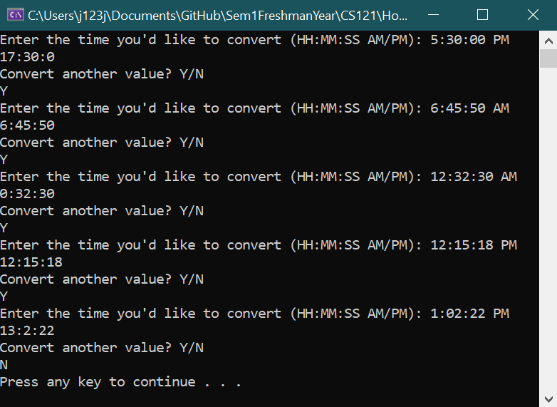

**Program 4. File Input and Output**

**Using the temps.txt data file which has temperatures in degrees Celsius create a new data file (table.txt) that consists of a table of temperatures in Celsius, Fahrenheit and Kelvin.**

**Code:**

//

// Program 4

//

#include <iostream>

#include <fstream>

#include <iomanip>

#include <string>

using namespace std;

float cToF(float celsius);

float cToK(float celsius);

int main(void)

{

float temp_c;

ifstream infile;

ofstream outfile;

infile.open("C:/Users/j123j/Documents/GitHub/Sem1FreshmanYear/CS121/Homework2/Program4/Temps.txt");

outfile.open("C:/Users/j123j/Documents/GitHub/Sem1FreshmanYear/CS121/Homework2/Program4/Table.txt");

if (!infile)

{

cout << "Error. Not able to open input file.";

system("pause");

return(3);

}

if (!outfile)

{

cout << "Error. Not able to open input file.";

system("pause");

return(3);

}

cout << "Files opened" << endl;

outfile << left << fixed << setprecision(2) << setw(20) << "Celsius"

<< setw(20) << "Farenheit" << setw(20) << "Kelvin" << endl;

while (!infile.eof())

{

infile >> temp_c;

outfile << setw(20) << temp_c << setw(20) << cToF(temp_c)

<< setw(20) << cToK(temp_c) << endl;

}

cout << "Processing complete" << endl;

infile.close();

outfile.close();

cout << "Files closed" << endl;

system("pause");

return 0;

}

float cToF(float celsius)

{

return 9.0f / 5.0f * celsius + 32.0f;

}

float cToK(float celsius)

{

return celsius + 273.15f;

}

**Output:**

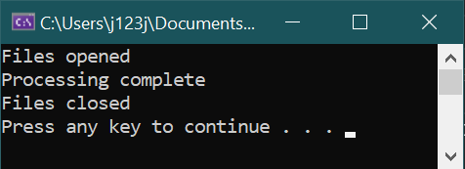

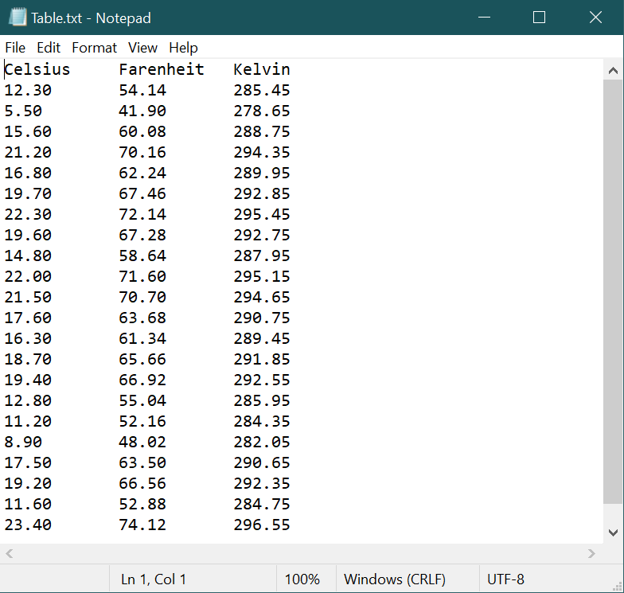 Also see submitted file

**Program 5. Spell Checker**

**Write a program that employs the four letter word dictionary to check the spelling of an input word (test word).**

**Code:**

//

// Program 5

//

#include <iostream>

#include <fstream>

#include <iomanip>

#include <string>

using namespace std;

int main(void)

{

ifstream dictionary;

string restart;

dictionary.open("C:/Users/j123j/Documents/GitHub/Sem1FreshmanYear/CS121/Homework2/Program5/Dictionary.txt");

if (!dictionary)

{

cout << "Error. Not able to open file.";

system("pause");

return(3);

}

do

{

string word, input;

cout << "Enter a four letter word to check it's spelling: ";

cin >> input;

do

{

dictionary >> word;

} while (word != input && !dictionary.eof());

if (word == input) cout << "The word was spelled correctly" << endl;

else cout << "The word was not spelled correctly" << endl;

cout << "Check another word? Y/N ";

cin >> restart;

dictionary.clear();

dictionary.seekg(0, ios::beg);

} while (restart == "Y");

dictionary.close();

system("pause");

return 0;

}

**Output:**

